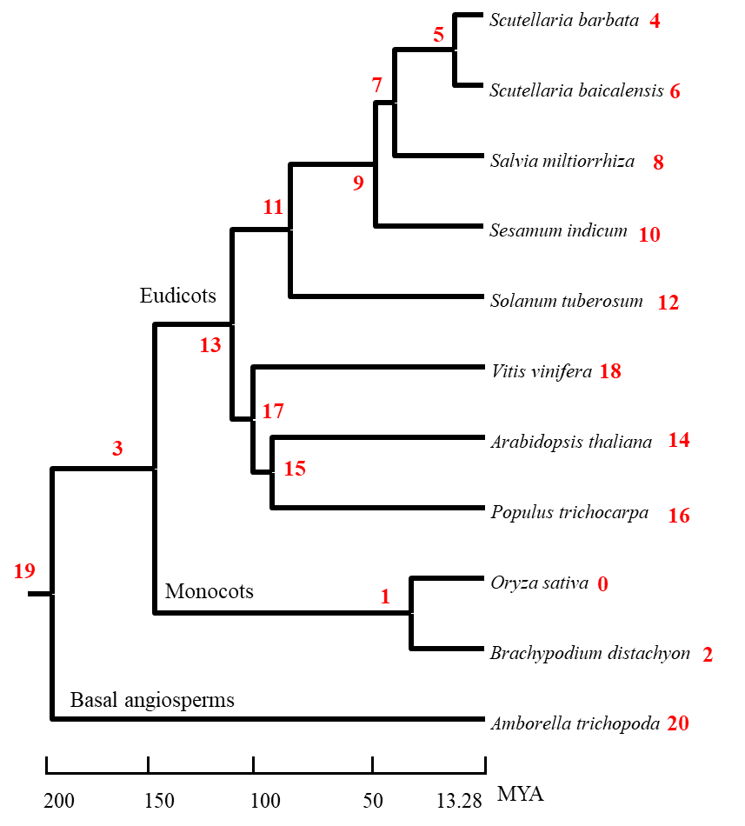

Supplementary Figure S8. The Gene family expansion and contraction of candidate species according to phylogenetic analysis (*P* < 0.01). The number of expansion and contraction events of 20 nodes are listed in Table S10.